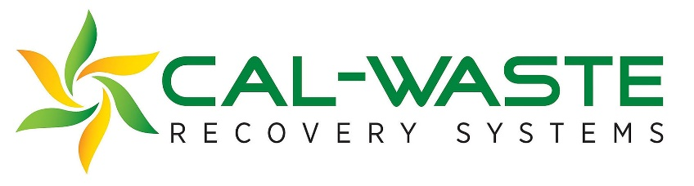
Official use only:
Received:
Complete:
A3:_____________
B4:_____________
C5:_____________
DT:_____________
Vocational Scholarship Application

First Name:
Middle Name:
Last Name:
Date:
High School Currently Attending:
Current Grade Level:
Student ID #:
Home Phone (with area code):
Cell Phone (with area code):
Home Address:
Email Address:
Preferred Method of Contact:

Information given on this application will be used to consider you for a Vocational Scholarship. It will supplement any existing financial aid application you have or may file. The scholarship award will be issued directly to the community college or vocational training financial aid office and will be awarded to the students after enrollment in the specified number of units at that institution. Both content and manner of presentation will be considered when this scholarship application is reviewed. The scholarship application should be typed or printed in black ink.
PLEASE READ AND COMPLETE THE ENTIRE APPLICATION
Failure to complete all sections of this form may jeopardize the status of your application. This application and one completed recommendation letter, preferably from a current or former instructor, are the only forms necessary to apply.

CAL-WASTE RECOVERY SYSTEMS: Vocational Scholarship Application Form

Personal Information

U.S. Citizen: Immigrant: Foreign Student: If yes, name of sponsor:
Do you live with parents: Live with relatives: Live with friends:

Father’s Full Name:_____________________________________________________________________
Father’s Home Address: _________________________________________________________________
Father’s Employer:______________________________________________________________________
Father’s Occupation:____________________________________________________________________
Mother’s Name:________________________________________________________________________
Mothers Home Address:_________________________________________________________________
Mother’s Employer:_____________________________________________________________________
Mother’s Occupation:___________________________________________________________________
Estimated total family annual income:______________________________________________________
- Mother’s Income:_________________________Father’s Income:_________________________

Education
School Currently Attending:
Dates of Attendance: Current GPA:
Have you ever participated in an internship program:
If yes, when and where:

Are you currently employed working a part of full time position:
If yes, where:

What Degree or Certificate are you seeking after graduation from High School:

From which College or Vocational Institution:
How many units will you be taking each term next year:
Total cost of per year for College or Vocational Institution you will be attending:____________________
When do you anticipate reaching your goal/graduation/certification:
Do you expect to continue your education after completion of your goal/graduation/certification:
CAL-WASTE RECOVERY SYSTEMS: Vocational Scholarship Application Form (cont.)
Memberships, Activities, and Involvement
List the activities in which you are actively participating or have participated in the past. Include both school or in the community (Example: clubs, athletics, committees, music, volunteer, fundraising, etc.)
SCHOOL |  |  |  |  | COMMUNITY
 | Grade |  |  |  |  | Grade
 | 9 | 10 | 11 | 12 |  | 9 | 10 | 11 | 12
Student Government/Council /Class Officer |  |  |  |  | Organizations/Clubs/Community Service
Clubs/Activities (member or officer) |  |  |  |  | Employment (paid or volunteer)
Athletic Teams/Cheer/Flag/Drill |  |  |  |  | Awards/Honors (other than community achievements)
Performing Arts/Music/Speech/etc. |  |  |  |  | Other Activities
Awards/ Honors/Other Achievements

CAL-WASTE RECOVERY SYSTEMS: Vocational Scholarship Application Form (cont.)

Personal Statement
Please use the space below to share with us your aspirations and commitment to your goals.
Please limit your statements to the space provided

Tell us about yourself:

Share why you wish to attend the school you have selected:

Describe what you see yourself doing 5 years from now:

Explain your plan and how you will attain these goals:

CAL-WASTE RECOVERY SYSTEMS: Vocational Scholarship Application Form (cont.)

Letter of Recommendation
Please share the name of the one person from whom you have requested a letter of recommendation. (current or former instructor)
Name:
Position:
Please have this person submit their letter of recommendation to:
leesaklotz@ cal-waste.com (preferred)
Or mail to:
Vocational Scholarship
Cal-Waste Recovery Systems
175 Enterprise Ave. Ste. A
Galt, CA 95632

Completion of Application
I hereby authorize the Financial Aid Office at the school(s) to which I am applying to release all information that may be requested concerning my application. I agree that some scholarship information may be sent to me at the email address I have listed.
Name (printed): ___________________________________________________________ Signature: ________________ Date:______________________
Please save a copy of this application form for your records.
Place “Vocational Scholarship (add your last name)” in the subject line, email your completed application as an attachment to:
leesaklotz@ cal-waste.com (preferred)
Or mail to:
Vocational Scholarship
Cal-Waste Recovery Systems
175 Enterprise Ave. Ste. A
Galt, CA 95632

