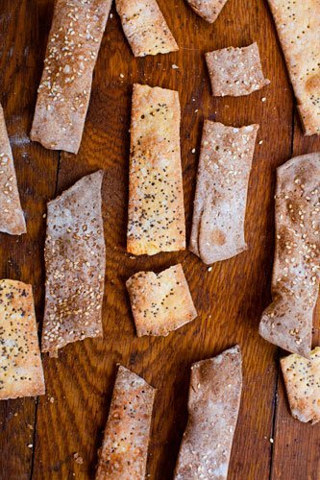
Parmesan, Cornmeal & Poppyseed Crackers
Yield: 7 ounces

Ingredient | Original Amount
AP flour | ½ c
Cornmeal | ½ c
Cool water | ¼ c 2 T
Parmesan Cheese | ¼ c
Butter | 1 ½ T
Kosher Salt | ¼ t + 1 pinch (plus more for topping)
Poppyseeds | 1 T

Instructions:
- Place the flour, cornmeal, cool water, cheese, butter, and kosher salt in a food processor and process until the mixture forms a ball, 2 to 3 minutes. Remove from the processor, cover with a towel to prevent drying, and let the dough rest at room temperature for at least 30 minutes.
- Preheat the oven to 400 degrees F.
- On a lightly floured work surface, roll out the dough very thinly and evenly, flipping it over and continuing to roll while adding more flour as needed if the dough sticks. Stop rolling just short of 1/8 inch thick.
- Sprinkle the dough lightly with the poppy seeds and additional salt and continue to roll just to embed the salt and seeds into the dough.
- Cut into strips about 2 inches wide and poke the strips evenly in several places with the tines of a fork.
- Using both hands, pick up either end of each strip carefully and lay it down on a parchment lined baking sheet. Bake until the crackers begin to brown and become crisp (15-18 minutes), keeping in mind that the crackers will continue to crisp up as they cool.
(If they don’t crisp up properly after they cool slightly, you can put them back in the oven for a few minutes)
- Let the crackers cool completely and break them into irregular shards of the desired size and shape.
Store in an airtight container; should stay crisp for up to 2 weeks at room temperature.
Source: Durand, Faith. "Cornmeal, Parmesan, and Poppy Seed Crackers: D.I.Y. Delicious by Vanessa Barrington - Cookbook Recipe & Review." N.p., n.d. Web. 24 Feb. 2016.

